ABSTRACT

A signature of a person is simply a handwritten sign or marks that resembles to his/ her name often stylized and unique and indicates person’s identity, intent, and consent. Mostly used for different purpose like authenticating checks, drafts, certificates, approvals, letters, and other legal documents. Since signature are used in such critical activities, confirmation of their authenticity are significantly important.

Traditionally signature was manually compared with copies of genuine signatures for verification. This simple method may not be sufficient as the technology is becoming more and more advance and with advancing techniques of forgeries and falsification of signature. So, in order to tackle such problem new efficient tool is needed and this project proposes such signature verification tool which can assist human in correct decision making in authentication of handwritten signature.

For such authentication of signature this project presents an applications of which facilitates the feature of human signature verification using the convolution neural network approach. This software is able to train the network with new dateset of signature and validate the authenticity of new signature of trained class. User can also perform experiment and analyze the training and verification of model with features result analysis feature. This software consists very efficient user interface so that any non-technical person can use the software without any difficulty. The end result of project was very optimistic and it encourages us for further research and development in this field.

TABLE OF CONTENTS

ACKNOWLEDGEMENT i
ABSTRACT ii
TABLE OF CONTENTS iii
LIST OF FIGURES iv
1. INTRODUCTION 1
2. LITERATURE REVIEW 2
3. SIGNATURE IMAGE GENERATION 3
3.1 System Description 4
4. METHODOLOGY 5
5. MODULE DESCRIPTION 6
6. PROPOSED METHODOLOGY 10
6.1 Algorithm 10
6.2 Mathematical Model 11
7. WORKING PRINCIPLE 12
8. RESULT AND DISCUSSION 14
8.1 Graphical User Interface (GUI) 14
8.2 Proposed System Result 16
8.3 Existing System Result 16
9. CONCLUSION 17
10. FUTURE WORKS 18
REFERENCES 19

LIST OF FIGURES

Figure 3.1 Signature Image Generation 3
Figure 4.1 Project Overflow 5
Figure 5.1 Workflow of CNN 6
Figure 5.2 Input Layers 7
Figure 8.1 GUIs (a) , (b) , (c) , (d) , (e), (f) .......... 15
Figure 8.2 Signature Accuracy Match Bar 16

1. INTRODUCTION

Traditional bank checks, bank credits, credit cards and various legal documents are an integral part of the modern economy. They are one of the primary mediums by which individuals and organizations transfer money and pay bills. Even today all these transactions especially financial require our signatures to be authenticated.

Signature verification can be considered a special case of pattern recognition. Like in any pattern recognition problem, in signature verification distinctive features can be extracted from a set of original signatures. However, Approaches to signature verification fall into two categories: On-line and Off-line. There are two types of signatures, offline (static) and online (dynamic). Online signatures have higher distinctive features but offline signatures have fewer distinctive features. With the development of machine learning, new algorithms present promising solutions that can be used for signature verification. For these reasons, signature verification is one of the most important problems remains to be solved in machine learning methods nowadays. The most important drawback of offline signatures is that they cannot be reproduced in the same way.

In this study we will take the dataset of the different signatures. We will take signature as an input in the form of image. After taking signature as an input next step is feature extraction. Signature is separated according to the features. After extracting the features, matching process is done. According to the matching result is implemented. And final output is recognition of signature.

Main motivation of the system is to provide security to the signatures which are widely used in legal documents, banking and commercial transactions. Normally it is difficult to identify the signature of the particular user at the time of verification of the documents. At that time, there is a need to identify the fake signatures from the documents. So there must be some system or application which would help banking system and some other systems like commercial transaction to detect the fake signature. This system is also helpful to provide more security at the time of all transactions and also at the time some property issues.

2. LITERATURE REVIEW

The area of Handwritten Signature Verification has been broadly researched in the last decades and still remains as an open research problem. This project focuses on offline signature verification, characterized by the usage of static (scanned) images of signatures, where the objective is to discriminate if a given signature is genuine (produced by the claimed individual) or a forgery (produced by an impostor). We present an overview of how the problem has been handled by several researchers in the past few decades and the recent advancements in the field.

Article published in International Journal of Scientific & Engineering examined signature verification using neural network approach and analyzed its strengths and weakness. Paper presented method which uses geometric features extracted from preprocessed signature images, which trained neural network using error back propagation training algorithm for verification of signature. They used a feature vector of dimension 60 to uniquely characterize a candidate signature. Article used different technique for verification analyzing different error rate: False Acceptance Rate (FAR), False Rejection Rate (FRR) and Correct Classification Rate (CCR).Result of research was 12% FAR, 16.7% FRR and Correct Classification Rate is 85.7%.

Research paper of topic “Signature Verification System (SVS) using CNN” proposed a new method for offline handwritten signature retrieval based on curvelet transform. It focused on applications of image processing with similarity retrieval of an image from large collections of images. In such case image indexing become important for efficient organizational and retrieval of images. The proposed 4system used a curvelet based texture feature extraction. The performance of the system was tested with an image database of 180 signatures. The result obtained indicated that the proposed system was able to identify signatures with greater accuracy even when part of signature was missing

3. SIGNATURE IMAGE GENERATION

“Synthetic off-line Signature Image Generation” - This paper proposes a novel methodology to generate static/off-line signatures of new identities. The signature of the new synthetic identity is obtained particularizing the random variables of a statistical distribution of global signature properties. The results mimic real signature shapes and writing style properties, which are estimated from static signature databases. New instances, as well as forgeries, from the synthetic identities are obtained introducing a natural variability from the synthetic individual properties. As additional novelty, an ink deposition model based on a ball point is developed for realistic static signature image generation. The range of the static signature generator has been established matching the performance obtained with the synthetic databases and those obtained with two public Databases.
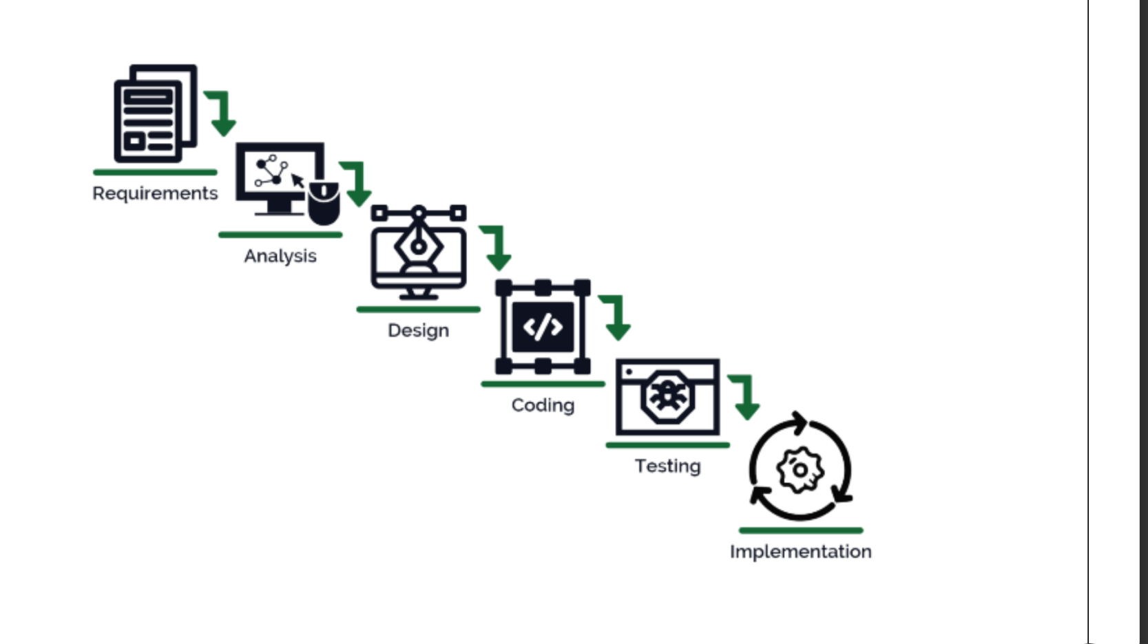

Figure 3.1 Signature image generation

3.1 System Description

The system comprises 2 major modules with their sub-modules as follows:

USER:
- Sign In:
The user would need to sign in using their: Name, Number, Email, Password, Username, Photo and Age.

- Login:
The user can log in after signing in.

- Start Matching:
- The user will fill in two images, one will be the original image, and the second will be the comparison image.
- The system will direct users to the results page to see the results.

4. METHODOLOGY

Project Workflow :
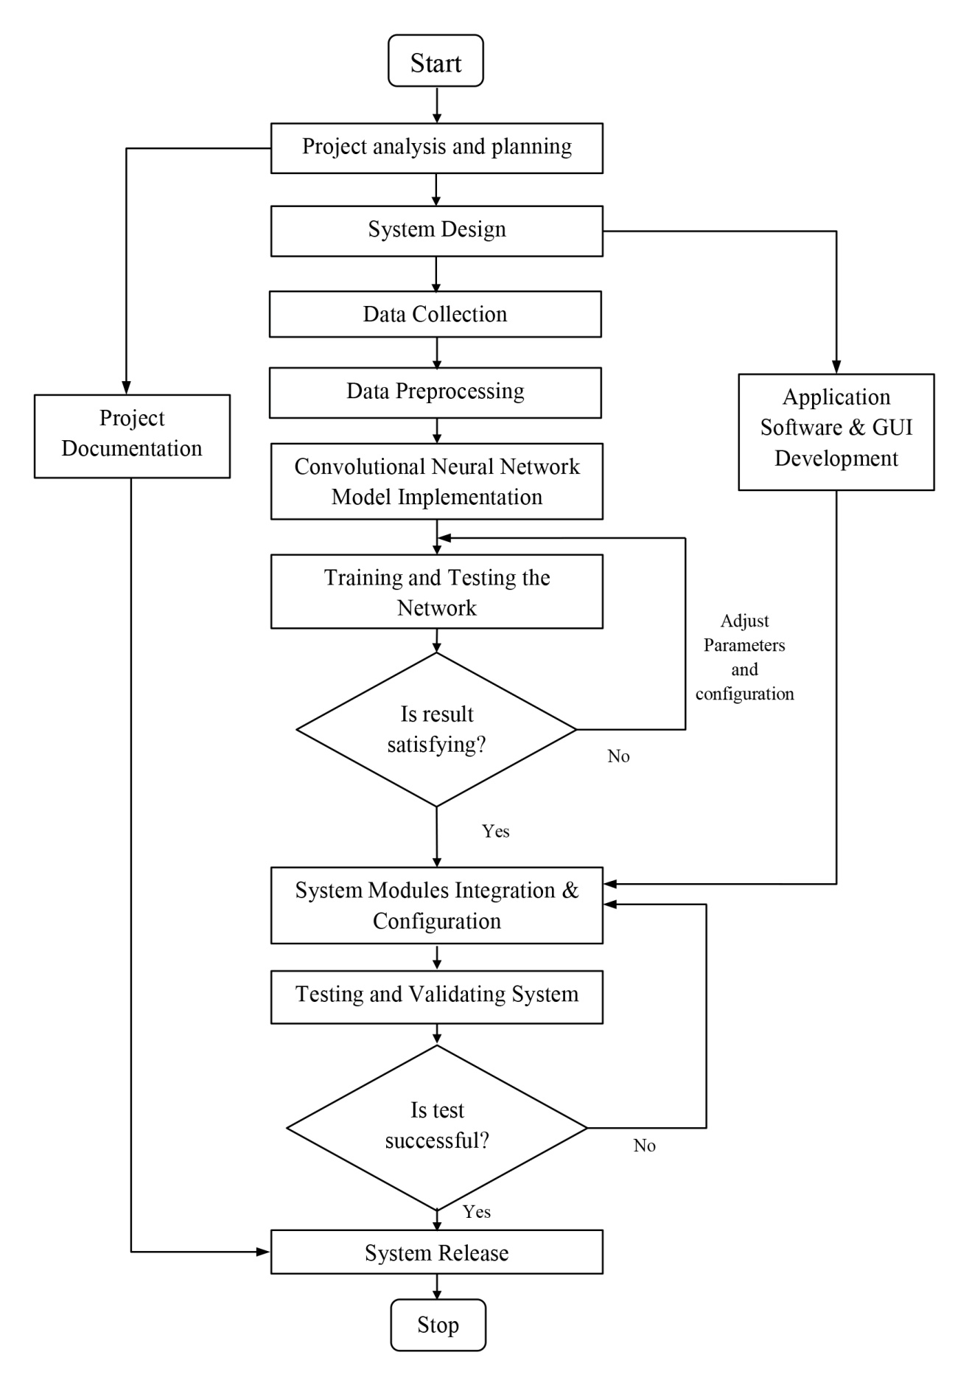

Figure 4.1 Project Overflow

5. MODULE DESCRIPTION

1. IMPORT THE IMAGE FROM DATASET AND TRAINING MANUAL CNN
We have to import our data set using keras preprocessing image data generator function also we create size, rescale, range, zoom range, horizontal flip. Then we import our image dataset from folder through the data generator function. Here we set train, test, and validation also we set target size, batch size and class-mode from this function we have to train using our own created network by adding layers of CNN.

2. TO TRAIN THE MODULE BY USING ALEXNET
To train our dataset using classifier and fit generator function also we make training steps per epoch’s then total number of epochs, validation data and validation steps using this data we can train our dataset. Training the module using Alexnet CNN.

3. TO TRAIN THE MODULE BY USING LENET
A Convolutional Neural Network (CNN) is a Deep Learning algorithm which can take in an input image, assign importance (learnable weights and biases) to various aspects/objects in the image and be able to differentiate one from the other. The pre-processing required in a ConvNet is much lower as compared to other classification algorithms. While in primitive methods filters are hand-engineered, with enough training, ConvNets have the ability to learn these filters/characteristics. The architecture of a ConvNet is analogous to that of the connectivity pattern of Neurons in the Human Brain and was inspired by the organization of the Visual Cortex. Individual neurons respond to stimuli only in a restricted region of the visual field known as the Receptive Field. Their network consists of four layers with 1,024 input units, 256 units in the first hidden layer, eight units in the second hidden layer, and two output units.
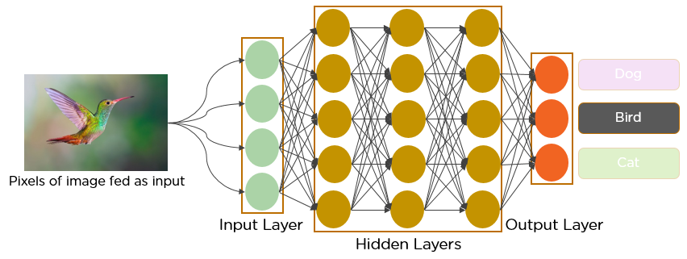

Figure 5.1 Workflow of CNN
i. INPUT LAYER
Input layer in CNN contain image data. Image data is represented by three dimensional matrixes. It needs to reshape it into a single column. Suppose you have image of dimension 28 x 28 =784, it need to convert it into 784 x 1 before feeding into input.
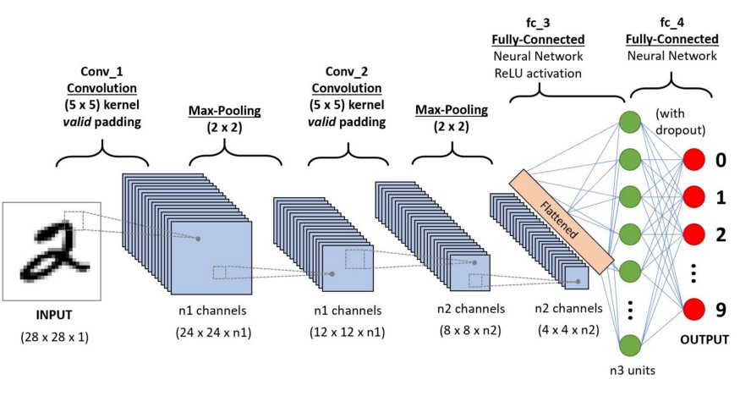

Figure 5.2 Input Layers

ii. CONVO LAYER
Convo layer is sometimes called feature extractor layer because features of the image are get extracted within this layer. First of all, a part of image is connected to Convo layer to perform convolution operation as we saw earlier and calculating the dot product between receptive field (it is a local region of the input image that has the same size as that of filter) and the filter. Result of the operation is single integer of the output volume. Then the filter over the next receptive field of the same input image by a Stride and do the same operation again. It will repeat the same process again and again until it goes through the whole image. The output will be the input for the next layer.

iii. POOLING LAYER
Pooling layer is used to reduce the spatial volume of input image after convolution. It is used between two convolution layers. If it applies FC after Convo layer without applying pooling or max pooling, then it will be computationally expensive. So, the max pooling is only way to reduce the spatial volume of input image. It has applied max pooling in single depth slice with Stride of 2. It can observe the 4 x 4 dimension input is reducing to 2 x 2 dimensions.

iv. FULLY CONNECTED LAYER (FC)
Fully connected layer involves weights, biases, and neurons. It connects neurons in one layer to neurons in another layer. It is used to classify images between different categories by training.

v. SOFTMAX / LOGISTIC LAYER
Softmax or Logistic layer is the last layer of CNN. It resides at the end of FC layer. Logistic is used for binary classification and softmax is for multi-classification.

vi. OUTPUT LAYER
Output layer contains the label which is in the form of one-hot encoded. Now you have a good understanding of CNN.

4. DEPLOYING THE MODEL IN DJANGO FRAMEWORK AND PREDICTING OUTPUT
In this module the trained deep learning model is converted into hierarchical data format file which is then deployed in our Django framework for providing better user interface and predicting the output whether the given signature is genuine or forged. Implementation General Requirements are the basic constrains that are required to develop a system. Requirements are collected while designing the system. The following are the requirements that are to be discussed.
- Functional Requirements
- Non-Functional Requirements
- Environment Requirements

FUNCTIONAL REQUIREMENTS
The software requirements specification is a technical specification of requirements for the software product. It is the first step in the requirements analysis process. It lists requirements of a particular software system. The following details to follow the special libraries like tensorflow, matplotlib.

NON-FUNCTIONAL REQUIREMENTS
Process of functional steps,
- Problem define
- Preparing data
- Evaluating algorithm
- Improving results
- Prediction the result

SOFTWARE REQUIREMENT
Library requirements
- Tkinter
Tkinter is a Python package that is used to create graphical user interfaces (GUIs.
- cv2
CV2 is a Python library that provides access to the OpenCV computer vision library. CV2 can be used to load, display, resize, crop, and rotate images. It can also be used to perform more advanced image processing tasks, such as filtering, blurring, and sharpening images.
- Numpy
NumPy is a Python library used for working with arrays. It also has functions for working in domain of linear algebra, fourier transform, and matrices.
- CSV
The csv module implements classes to read and write tabular data in CSV format.
- pandas
Pandas is a Python library used for working with data sets. It has functions for analyzing, cleaning, exploring, and manipulating data.
- Matplotlib
Matplotlib is a comprehensive library for creating static, animated, and interactive visualizations in Python.
6. PROPOSED METHODOLOGY
The proposed system is as shown in fig. It consist of various activities. First the camera captured input image is taken for processing and after pre-processing with basic image operation same image is mapped to CNN trained model to get the prediction of which user the image is and if signature is authorized or not. The proposed system is designed to help these organizations, which are depending on the signatures to complete the documentation and transactions. The basic ideology is integrating the principle of CNN with the input signature image to verify and identify accurate result of signatures. To overcome the problems faced in existing system we are going to implement our system. In this system we are going to use CNN algorithm to get correct output. In this system we are going to minimize the human interpretation error. By using this system, it should be easy to find out the frauds and duplicates signature easily.

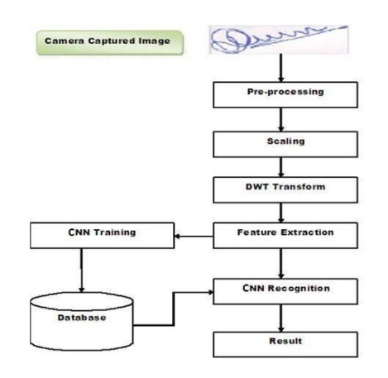

6.1 Mathematical Model

Let S be the closed system defined as, S = {Ip, Op, A, Ss, Su, Fi} Where, Ip=Set of Input, Op=Set of Output, Su= Success State, Fi= Failure State and A= Set of actions, Ss= Set of user’s states.

Set of input=Ip={username, password}
Set of actions =A={F1,F2,F3,F4,F5,F6}
Where,
F1= Authentication of user
F2 = input the signature image
F3 = system detect the object this image
F4 = Perform operation Image Processing and Machine Learning
F5= Detecting of various sources
F6= This result show and stored the database

Set of user’s states=Ss={registration state, login state, selection signature image, classified image, logout}
Set of output=Op={Show results}
Su=Success state={Registration Success, Login Success }
Fi=Failure State={Registration failed, Login failed}
Set of Exceptions= Ex ={Null Pointer Exception while registration state, Record Not Found (Invalid Password) while login state, Null Values Exception while showing state}

WORKING PRINCIPLE

Training Dataset

# Read the CSV file into a pandas DataFrame (Training Dataset)
df = pd.read_excel('C:/Users/arunk/OneDrive/Desktop/arunprojectfolder/sign.xlsx',header=None)
print(df)
path = df.values.tolist()
original_path = [[url.replace("file:///", "") for url in row] for row in path]

Implementation CNN Mechanism
# img_counter = 0
while True:
ret, frame = cam.read()
if not ret:
print("failed to grab frame")
break
cv2.imshow("test", frame)
k = cv2.waitKey(1)
if k % 256 == 27: # ESC pressed
print("Escape hit, closing...")
break
elif k % 256 == 32: # SPACE pressed
if not os.path.isdir('temp'):
os.mkdir('temp', mode=0o777) # make sure the directory exists
if(sign == 1):
img_name = "./temp/test_img1.png"
else:
img_name = "./temp/test_img2.png"
print('imwrite=', cv2.imwrite(filename=img_name, img=frame))
print("{} written!".format(img_name))
cam.release()
cv2.destroyAllWindows()
return True

def captureImage(ent, sign=1):
if(sign == 1):
filename = os.getcwd()+'\\temp\\test_img1.png'
else:
filename = os.getcwd()+'\\temp\\test_img2.png'
# messagebox.showinfo(
# 'SUCCESS!!!', 'Press Space Bar to click picture and ESC to exit')
res = None
res = messagebox.askquestion(
'Click Picture', 'Press Space Bar to click picture and ESC to exit')
if res == 'yes':
capture_image_from_cam_into_temp(sign=sign)
ent.delete(0, tk.END)
ent.insert(tk.END, filename)
return True

# Generate the auracy value will convert into a pdf form

pdf = FPDF()
pdf.l_margin=5
pdf.r_margin=0

# Add a page
pdf.add_page()

# Set font for the entire document
pdf.set_font("Arial", size=25,style='B')

# Add a cell
# pdf.cell(200, 10, txt="", ln=True, align='C',border=0)
pdf.set_font("Arial", size=12,style='B')

# Add another cell
pdf.cell(200, 10, txt="Signature Verification System", ln=True, align='C',border=1)

pdf.image("C:/Users/arunk/OneDrive/Desktop/arunprojectfolder/assets/4.png", x = 10, y = 40, w = 30)

pdf.image(path[0][0], x = 10, y = 40, w = 30)
pdf.image(path[0][1], x = 50, y = 40, w = 30)
pdf.cell(200, 20, txt="", ln=True, align='C',border=0)
pdf.cell(40, 10, txt="ORIGINAL", ln=False, align='C',border=0)
pdf.cell(40, 10, txt="SITTING", ln=False, align='C',border=0)

pdf.image('chart.png', x = 10, y = 120, w = 100)
pdf.output("C:/Users/arunk/OneDrive/Desktop/arunprojectfolder/Result.pdf")
8. RESULT AND ANALYSIS

In the proposed system, we will be using supervised CNN approach which further will improves the accuracy or predicted value. CNN is proved for better accuracies with supporting to the deep learning methods. It is also complemented with the light weight library in python for image processing as Open CV which help us to detect signs on paper automatically and improves the speed of execution.
- Model Performance Metrics:
- Provide a table summarizing the performance metrics of your CNN model on the test dataset. Include metrics such as accuracy, precision, recall, F1-score, and any other relevant measures.
- Highlight the overall performance of your model and compare it to baseline methods or previous research if applicable.
- Confusion Matrix:
- Present a confusion matrix to visualize the distribution of how percentage will be matching the signature true positive, true negative, false positive, and false negative predictions.
- Discuss any patterns or trends observed in the confusion matrix and how they reflect the performance of the model.
- Accuracy Across Classes:
- If your dataset contains multiple classes of signatures (e.g., genuine vs. forged), analyze the accuracy of the model for each class.
- Identify any classes where the model performs particularly well or poorly and discuss possible reasons for these disparities.
- Learning Curve Analysis:
- Plot the training and validation loss curves across epochs to visualize the learning progress of your model.
- Discuss any trends or patterns observed in the learning curves, such as overfitting or underfitting, and how you addressed them during training.
- Examples of Correct and Incorrect Predictions:
- Provide sample images from the test dataset along with their predicted labels and ground truth labels.
- Highlight instances where the model made correct predictions as well as cases where it failed to correctly classify the signature.
- Discuss any common characteristics or features of the signatures that may have influenced the model's predictions.
- Statistical Significance Testing:
- If you conducted experiments to compare multiple models or variations of your CNN architecture, perform statistical significance testing (e.g., t-tests) to assess the significance of differences in performance.
- Report the results of the significance tests and discuss their implications for model selection or optimization.

8.1 Graphical User Interface (GUI)
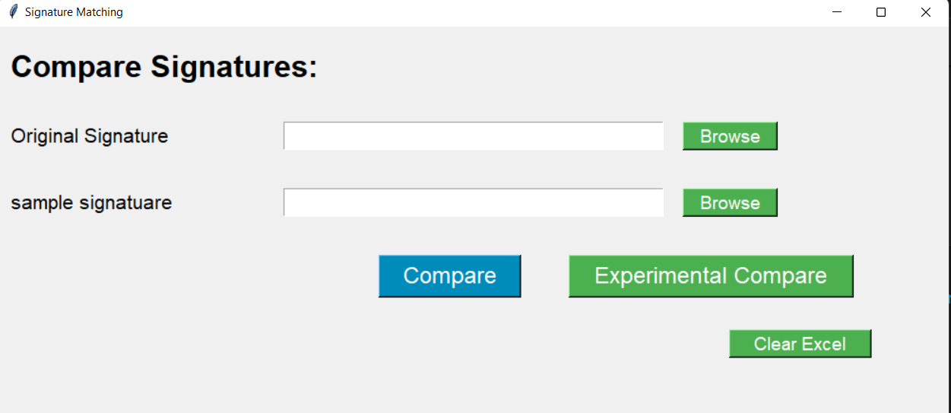

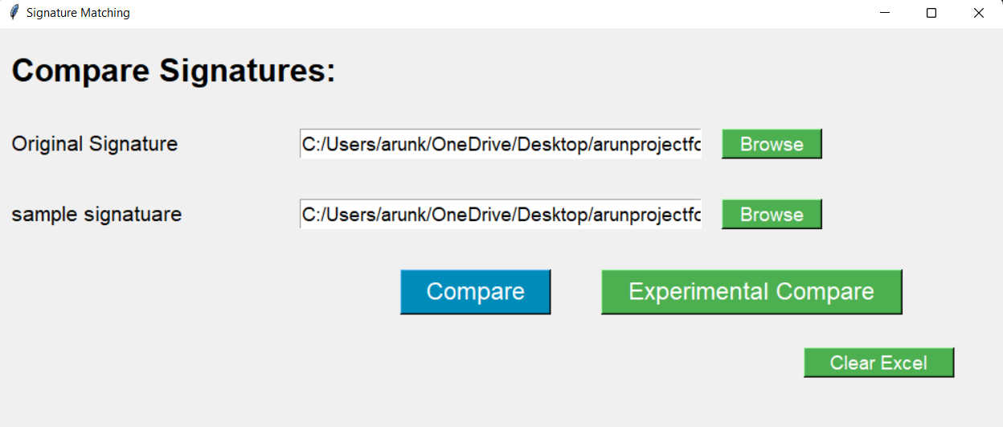
- User Interface

- Input the image

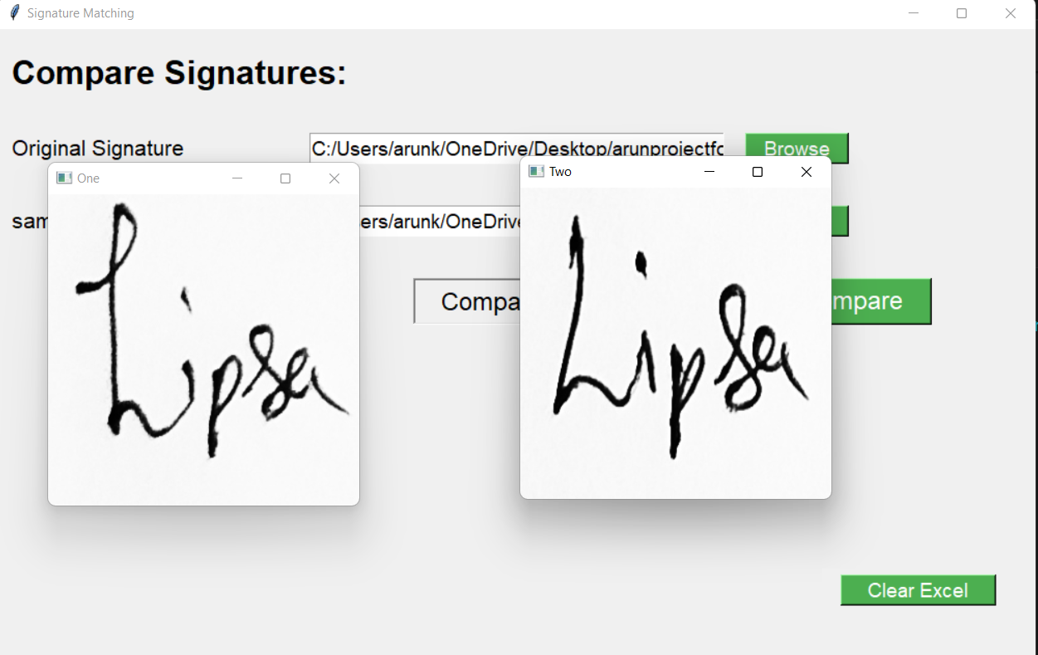

- Preview the Image

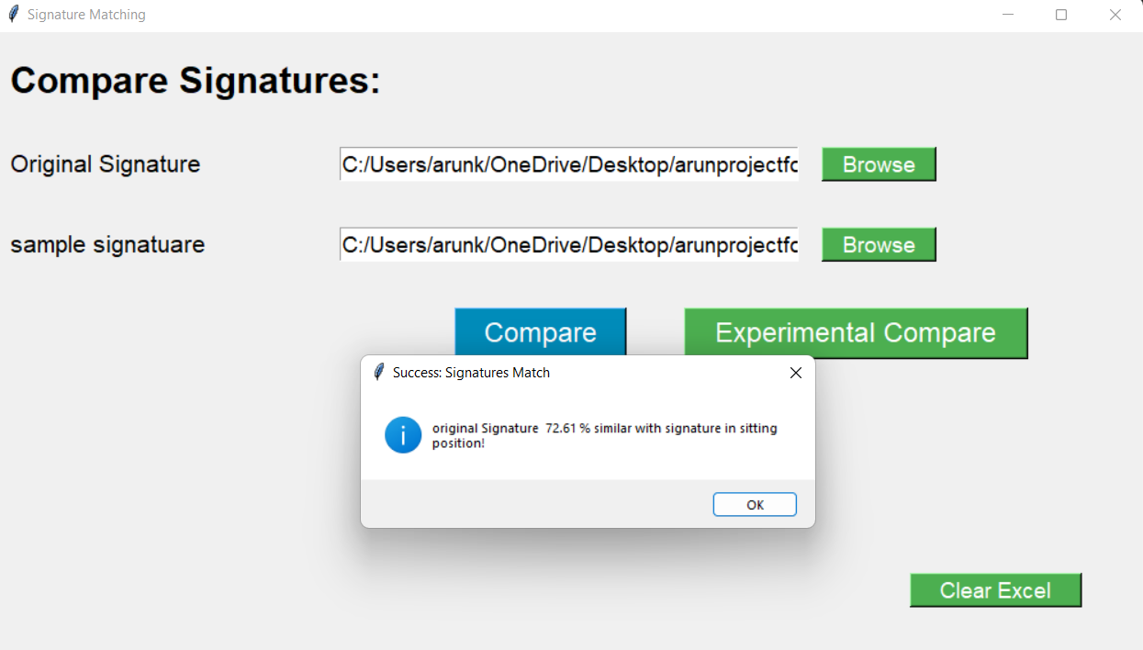

- Check the Result (Genuine or Forgery)

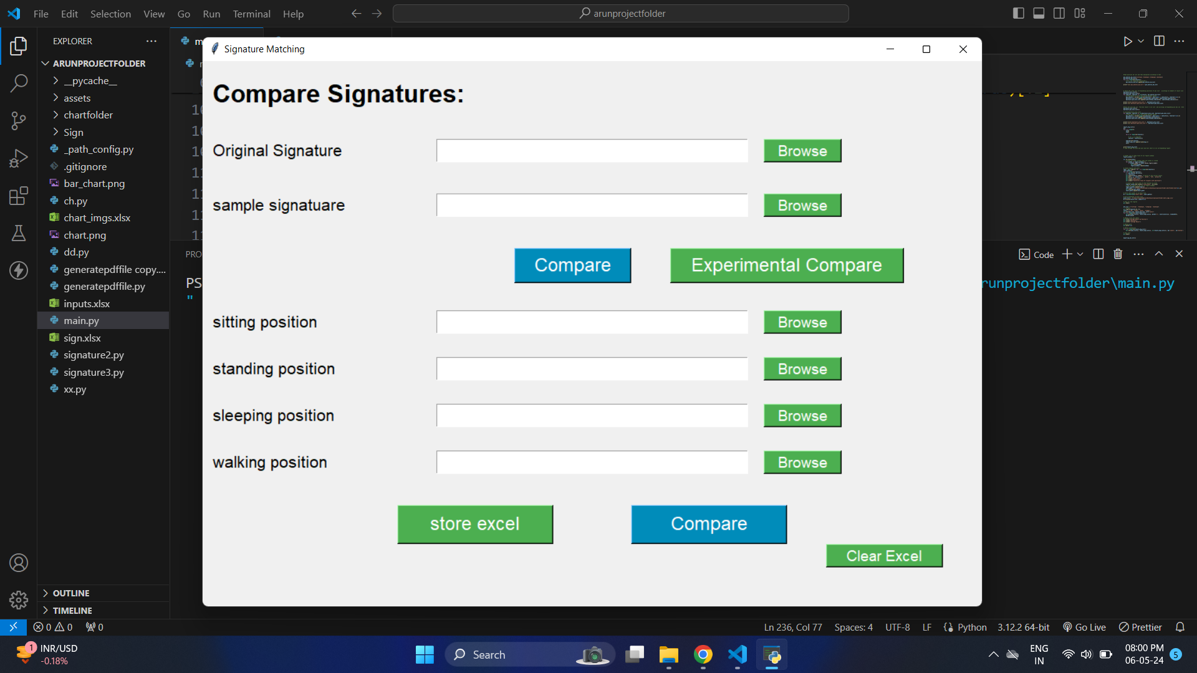

- Compare signature with Different type of position
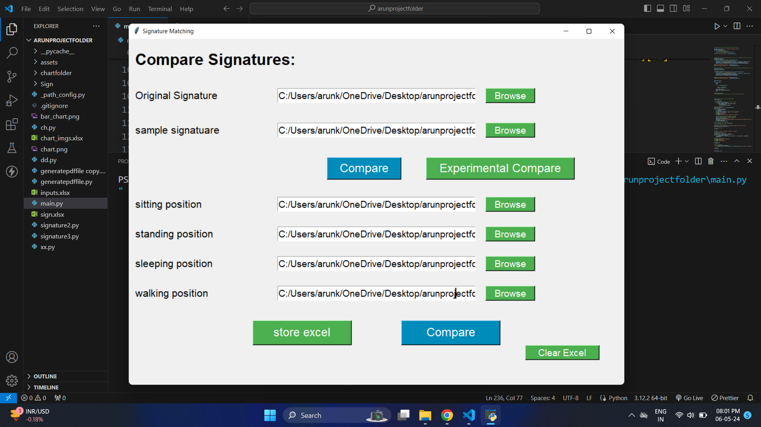

(F) Compare the Different type of Position
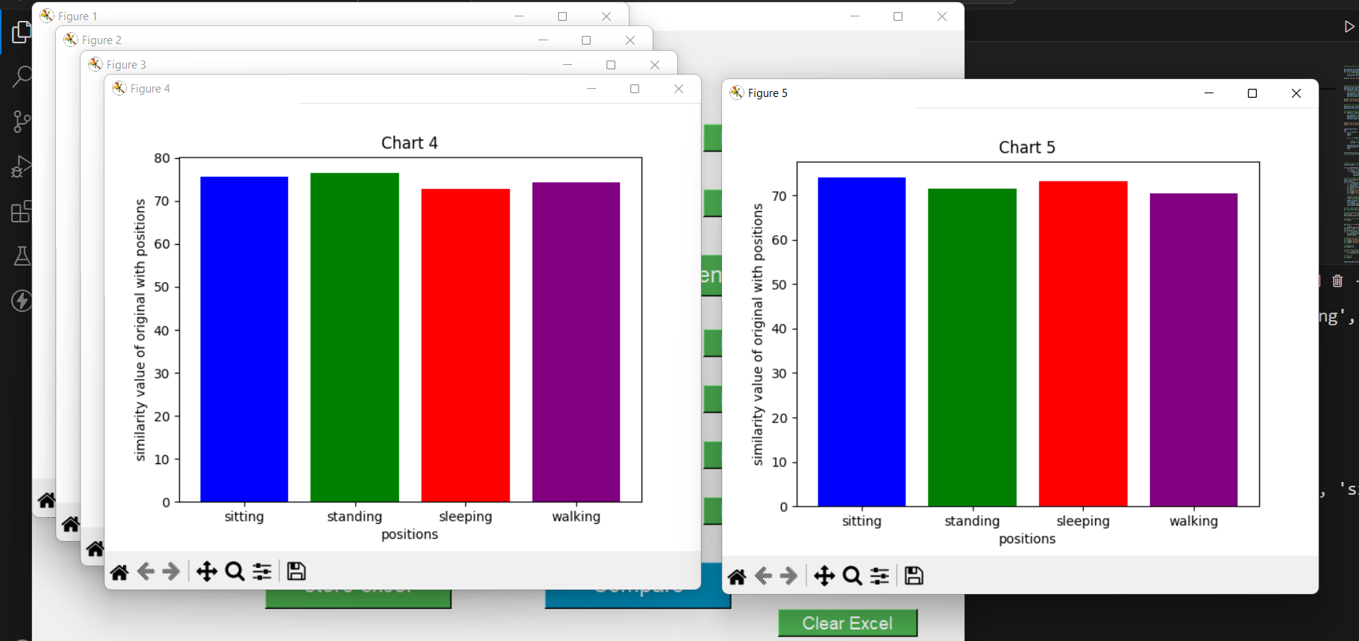

(G) Accuracy matching in the Bar Chart Format

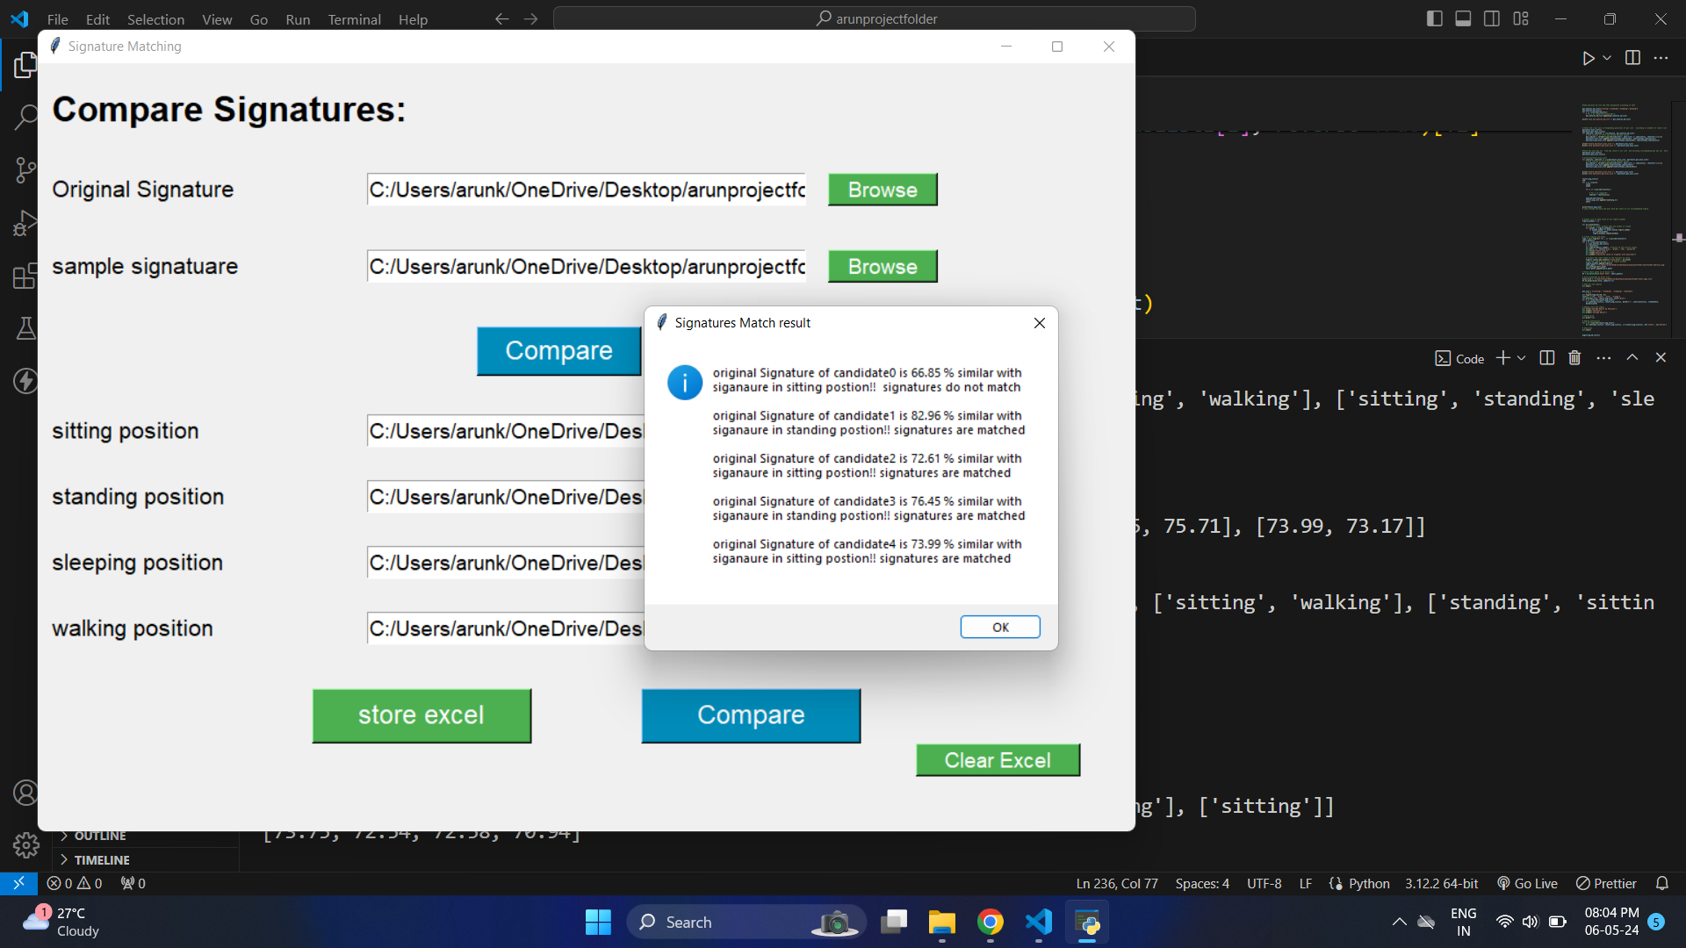

- Result condition check and percentage value
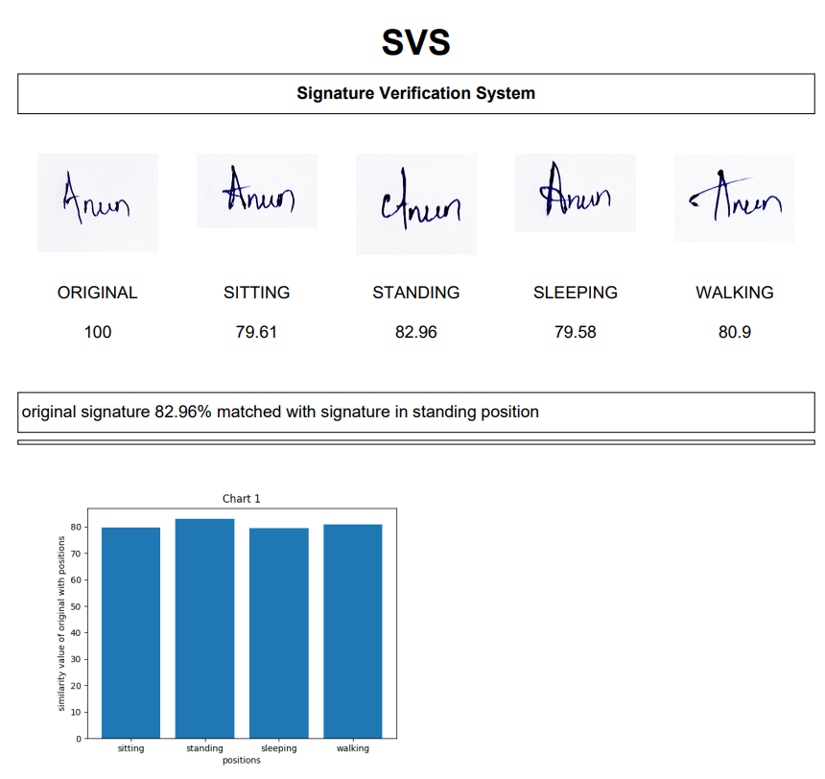

- Generate with PDF Format

Figure 8.1 GUIs Interface
- User Interface,
- Input the image,
- Preview the image
- Check the Result (Genuine or Forgery)
- Compare signature with Different type of position
- Compare the Different type of Position
- Accuracy matching in the Bar Chart Format
- Result condition check and percentage value
- Generate with PDF Format

Comparative results of existing and proposed system is as follow,
Parameters | Existing System | Proposed System
Automatic signature detection | No | Yes
Use of Open CV | Somewhat | Yes
CNN | No | Yes
Improved speed | No | Yes
Light Weight | No | Yes

With reference to Table it is clear that we overcome various problems in existing system and our approach works efficiently.

8.2 Proposed System Result

After training the images of the signatures using CNN, the database consisting of the signatures are tested and the result displays whether the corresponding signature is genuine or forged.

8.3 Existing System Result

The samples were divided randomly into the learning set and the testing set. All forged samples were included in the testing set. The correct verification rate obtained through the experiments. The experiment (learning and testing) results reveal the following interesting facts about the system.

- Average Signature Matrices:
- Describe how you calculated the average signature matrices for each position (sitting, standing, walking, sleeping) using the signatures of the 10 students.
- Explain the process you followed to ensure consistency and accuracy in computing these averages.
- Visualization of Average Signature Matrices:
- Provide visual representations of the average signature matrices for each position. This could be in the form of heatmaps or grayscale images, where darker regions represent areas with higher ink density.
- Discuss any noticeable patterns or differences between the average signature matrices for different positions.
- Comparison with Original Signatures:
- Explain how you used the average signature matrices to compare with the original signatures of individuals.
- Describe the method you employed to measure the similarity or match between an individual's signature and the average signature matrix for each position.
- Evaluation Metrics:
- Present the results of your comparison, including any similarity scores or metrics used to quantify the match between original signatures and the average signature matrices.
- Discuss the performance of the matching algorithm and its effectiveness in identifying signatures corresponding to different positions.
- Interpretation of Results:
- Interpret the findings from your comparison and discuss any insights gained from analyzing the match between original signatures and average signature matrices.
- Consider factors that may influence the match, such as variations in writing style or the complexity of the signature.

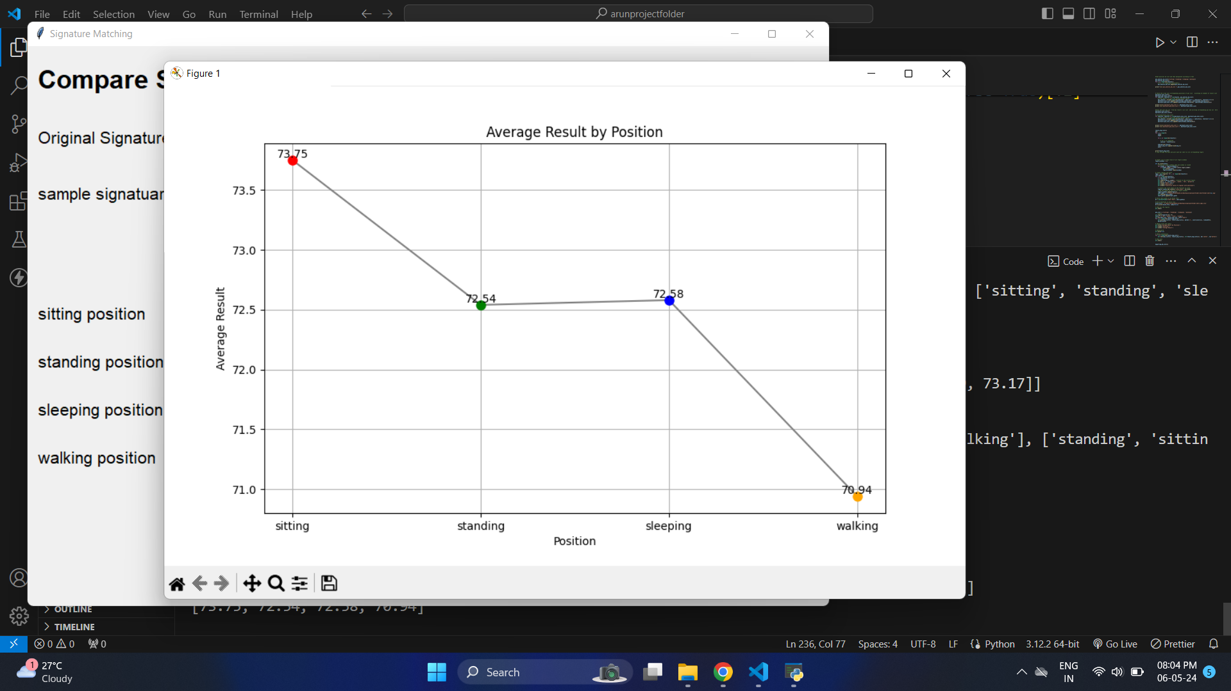

Figure 8.2 Signature Accuracy Match Bar

9. CONCLUSION

Throughout the most recent decade, there are many strategies for Offline Signature Verification. While recognizing genuine signatures and forged signatures remains a difficult task, false acceptance rates have dropped fundamentally in the most recent couple of years because of progressions in Deep Learning. We presented different formulations for learning representations for offline signature verification. Analyzing the above results, it shows that Conventional Neural Networks is better for classification of signature. The intuition to classify between genuine signatures and forgeries (regardless of the user), by learning the visual cues has improved the accuracy.

Hence from the above experimental results, this pattern will proceed for final work, with researchers proceeding to investigate better feature set (using Deep Learning networks), and approaches to improve arrangement with limited number of tests. Techniques based on ensembles of classifiers, specifically methods for dynamic choice are likewise encouraging procedure in this field.

Though the performance of the developed software is encouraging, the absence of online verification technique is realized as the inclusion of such dynamic features of online verification technique like pen’s speed, pressure, azimuth angle etc. would have significantly improved the verification performance and in coming future we are very eager to work on that.

Through the use of a convolutional neural network (CNN), offline signature verification has been carried out in this study. We can extract more accurate representations of the image content using neural network model called CNN. For improved categorization, CNN uses the image's raw pixel data to train a model before automatically extracting features. The biggest benefit In comparison to its forerunners, it automatically recognises the crucial details without human supervision and has the best level of image prediction accuracy. The GUI application is used for the uploading, training, and testing of the code using previously submitted data. Offline signature verification is made simple, quick, and clear using this method.

REFERENCES

- Dey Sounak, Dutta Anjan, J. Ignacio Toledo, Suman K. Ghosh, Josep Lladós and Umapada Pal, "Signet: Convolutional Siamese network for writer independent. Offline signature verification", CoRR, vol. abs/1707.02131, 2017.
- S Jerome Gideon, Anurag Kandulna, Aron Abhishek Kujur, A Diana and Kumudha Raimond, "Handwritten signature forgery detection using convolutional neural networks", Procedia Computer Science, vol. 143, pp. 978-987, 2018, ISSN 1877-0509.
- Keiron O'Shea and Ryan Nash, "An introduction to convolutional neural networks", CoRR, vol. abs/1511.08458, 2015.
- Karen Simonyan and Andrew Zisserman, "Very deep convolutional networks for large-scale image recognition", CoRR, vol. abs/1409.1556, 2014.
- Srinivasan Harish, Sargur N. Srihari and Matthew J. Beal, "Machine learning for signature verification" in Computer Vision Graphics and Image Processing, Berlin, Heidelberg:Springer Berlin Heidelberg, pp. 761-775, 2006, ISBN 978-3-54068302-5.
- M. Abadi, A. Agarwal, P. Barham, E. Brevdo, Z. Chen, C. Citro, G. S. Corrado, A. Davis, J. Dean, M. Devin et al., “Tensorflow: Large-scale machine learning on heterogeneous distributed systems,” CoRR, vol. abs/1603.04467, 2016.
- H. Baltzakis and N. Papamarkos, “A new signature verification technique based on a two-stage neural network classifier,” Engineering Applications of Artificial Intelligence, vol. 14, no. 1, pp. 95 – 103, 2001.
- A. Dutta, U. Pal, and J. Llads, “Compact correlated features for writer independent signature verification,” in 2016 23rd International Conference on Pattern Recognition (ICPR), Dec 2016, pp. 3422–3427.
- S. Ghandali and M. E. Moghaddam, “A method for off-line persian signature identification and verification using dwt and image fusion,” in 2008 IEEE International Symposium on Signal Processing and Information Technology, Dec 2008, pp. 315–319.
- Huang and H. Yan, “Off-line signature verification based on geometric feature extraction and neural network classification,” Pattern Recognition, vol. 30, no. 1, pp. 9 – 17, 1997.

